ACCELERATION

Acceleration (a): rate of change of velocity in a given direction.

It is a vector quantity and is calculated by the equation:

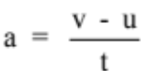

where a = acceleration in a given direction (ms⁻²)
u = initial velocity of the object (ms⁻¹)
v = final velocity of the object (ms⁻¹)
t = time taken for the change in velocity to occur (s)

This equation can also be written as:
v = u + at

Note
• When solving problems, pick one direction as the positive direction.

• Any vector in this direction is a positive value.

• Any vector in the opposite direction is a negative value.

Examples

1. A car moving at 30.0 kmh⁻¹ along a straight road accelerates uniformly to 70.0 kmh⁻¹ in 12.0 s. Calculate the acceleration experienced.

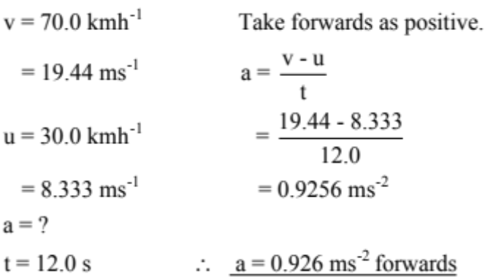

2. A car moving at 70.0 kmh⁻¹ along a straight road brakes suddenly to avoid a dog that
ran onto the road. It reduced its velocity to 15.0 kmh⁻¹ in 2.97 s and successfully
missed the animal. Calculate the deceleration of the car.

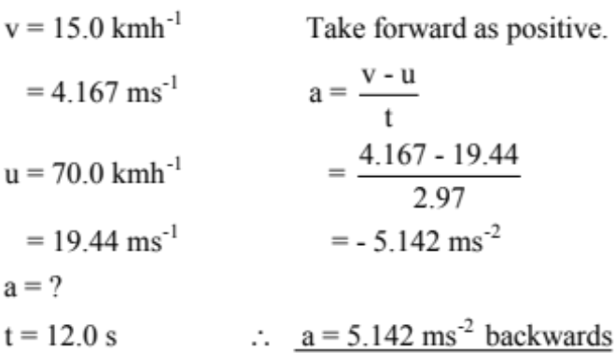

Note

The negative answer to the above example indicates that the acceleration is in the opposite direction to the direction chosen as positive (i.e. backwards).

Hence deceleration is an acceleration in the backwards direction, causing the car to slow.

If any answer to a problem is negative (and you are sure of your mathematics!), it means the vector is acting in the opposite direction to the positive direction you chose.

